**Telecom Customer Churn Analysis**



The analysis aims to analyze the churn rate of a telecom company, Connected S.A and identify the factors that contribute to customer churn. The dataset used in this analysis is the Connected S.A Telecom's Churn Dataset, which includes cleaned customer activity data and a churn label indicating whether a customer cancelled their subscription.

Problem Statement  
This project addresses the issue of customer churn at Connected SA Telecom. Customer churn refers to the proportion of customers who cancel their subscriptions within a given period. The goal of this analysis is to explore and interpret the data to identify the primary drivers of customer churn. Based on these insights, actionable recommendations will be proposed to help the company improve customer retention and reduce churn rates.

Business Objective  
The primary business objective of this project is twofold:

* **Identify the key drivers of customer churn:** By analyzing customer activity data, we aim to uncover patterns and correlations that explain why customers choose to discontinue their subscriptions. This insight will enable Connected SA Telecom to take proactive measures to mitigate churn.
* **Develop actionable strategies to improve customer retention:** Based on the analytical findings, we will provide practical, data-driven recommendations to help Connected SA Telecom retain its valuable customers. These may include targeted marketing initiatives, enhancements to customer service, or improvements to the service offering to address specific pain points.

# Data Analysis and Visualization:

Given the current dataset the customer base is made up of **3333 unique customers .**

**Overall** customer **churn rate is 14.5 % (483 customers)** according to market standards this is usually around 15 – 20% for the telcom industry while the company is below the industry standard there is always room for improvement. Customer acquisition is difficult so there should be an emphasis on retention on customers.

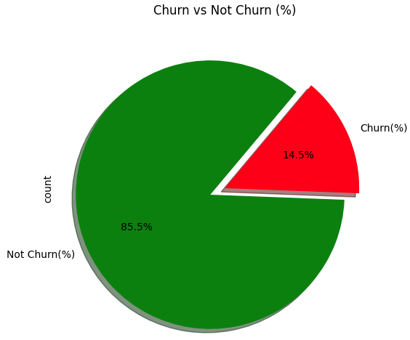

# Area Code Analysis:

Looking at the churn rate at an area code level it can be depicted that there are significant churn rates over the different area codes and can be disregarded for initial investigations.

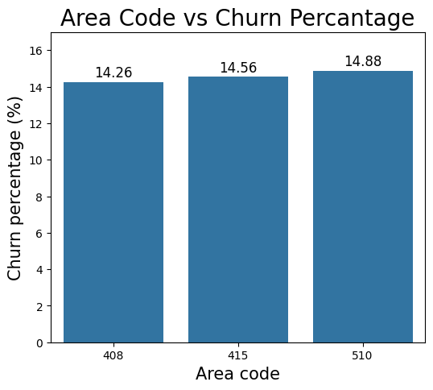

# Voice Plan Analysis:

2411 customers don’t have voice plans whereas 922 customers have voice plans.

27.7% of the companies customers don’t have a voice plan this is crucial as customers with voice plans have a 8.68% churn rate as compared to customers without a voice mail plan 16.72% this is more than double the churn rate % .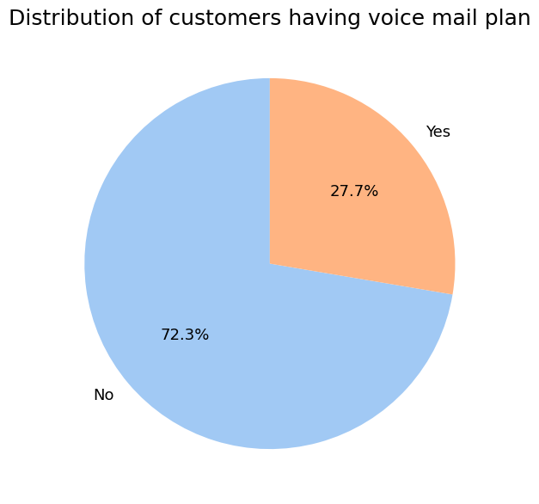

# Customer Churn by service call analysis:

Customers who have made more than 3 service calls have a very high churn rate ranging from 45 to 100% churn rate . This is indicative as the more the customer calls the more disatified they are this can be addressed as identifying problems which are requiring customers to call in numerous times . Customers who don’t make a service call have a 13% churn rate and they didn’t even attempt to resolve their problems this should be investigated further to understand if this was technical problems or customer experience problems for customer retention.

# Conclusions and Recommendations:

Retention of customers is easier and more maintainable than acquiring a new customer so analysis of customer churn is a crucial strategy in many businesses. Through exploratory data analysis, some key factors have been identified which are contributing to customer churn.

**Key findings :**

1. Area code has a minimal impact on customer churn rate with all area codes at a churn rate at around 14%.
2. Most of the customer base does not have a voice mail plan if we compare the customer churn rate for customers who have a voice mail plan and don’t it is seen that customers who have a voice mail plan have 8.68% churn rate which is more than half the churn rate of customers who don’t at 16.72% churn rate
3. Customers who make more than 3 service calls are very likely to churn with churn rates ranging between 45% to 100% as the service calls increase.